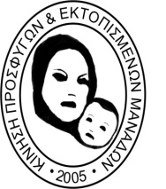
CYPRUS’ MOVEMENT OF REFUGEES & DISPLACED MOTHERS
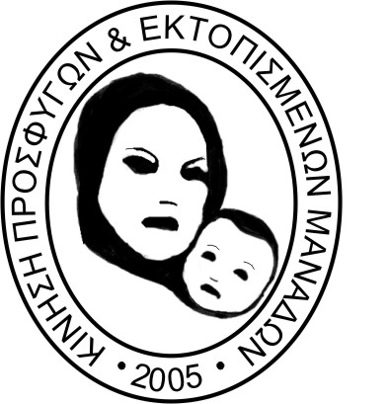
for the full restitution, conferment and respect of their fundamental human rights
ΚΙΝΗΣΗ ΠΡΟΣΦΥΓΩΝ & ΕΚΤΟΠΙΣΜΕΝΩΝ ΜΑΝΑΔΩΝ
Για για την πλήρη αποκατάσταση, διασφάλιση και σεβασμό των βασικών ανθρωπίνων δικαιωμάτων
P.O.Box 27540 – 2430 Eghomi – Nicosia, Cyprus
Tel: +357 99419317, +357 22667333, Fax: +357 22673074
email: info@mitrogonia.com www.mitrogonia.com Registration No.: 2907



Human Rights Council
Working Group on the Universal Periodic Review
Eighteenth session 27 January – 7 February 2014

REPUBLIC OF CYPRUS, National Report : A/HRC/WG.6/18/CYP/1

It is with deep regret that I have to inform the UPR that the Republic of Cyprus has not yet fully implemented the UPR’s, CEDAW’s, CRC’s recommendations stated on the above Report, specifically paragraphs 67 and 68.

Since the last review in 2009, followed by our recommendations on May 2012, the CYPRUS’ MOVEMENT OF REFUGEES & DISPLACED MOTHERS intensified the struggle by exercising continuous pressure to the Executive Body and Political Parties. As a result in December 12, 2013 the parliament voted 3 Bills amending the Civil Registry Law L 141(I)/2002. Specifically, amending article 119 recognizing the refugee status to the children of female refugees with the issuance of the Refugee Identity Card, however this amendment was EXCLUSIVELY for certain housing schemes (L155(I)/2011) excluding the recognition of any political or civil rights which are awarded to the children of male IDPs (article 107 of L141(I)2002).
Moreover Article 107 of the same Law referring to the political rights, is still not amended and remains discriminatory. Specifically, it states that only the children of male IDPs are eligible for registration to the occupied areas’ ballot thus depriving the children of female IDP’s of their fundamental right to vote and/or be elected in the occupied areas of their mothers’ decent, both in Parliamentary and Municipal elections.

As expected, the amendment of Article 119 (L 141(I)/2002 has been met with great satisfaction and is regarded as a success of our organization. Nevertheless, the ongoing gender discrimination has not been fully rectified.
Our present intervention aims to put an end to the ongoing discrimination and to exercise further pressure to the Republic of Cyprus to amend the said Article 107 Civil Registry Law L141(I)/2002, in order to grant our children equal political rights compared with the right awarded to the children of male IDPs. Our Organization will continue its struggle until the law is amended and until all forms of discrimination vis-a-vis the IDPs are eliminated.
May I point out the fact that while this is a state discrimination lasting ever since the aftermath of the 1974 Turkish invasion, a recent development is that the present government of the Republic of Cyprus has granted with a ministerial cabinet order this very right to the Turkish-Cypriots holders of the Republic of Cyprus’ identity Card to stand for the European Elections! Now how can this double standard be explained or more importantly seen and understood by our organization?

The CYPRUS’ MOVEMENT OF REFUGEES & DISPLACED MOTHERS continues its struggle until full vindication.

Thank you for your consideration

Markella Isaia-Chakka
President

31 January 2014

http://www.mof.gov.cy/mof/gpo/gpo.nsf/All/7A74A4973F1B3DA6C2257C4E0035303E/$file/4422%2027%2012%202013%20PARARTIMA%20PROTO%20MEROS%20I.pdf - Official Gazette No 4422 dated December 27,2013 Ν. 170(I)/2013 Νόμος που τροποποιεί τον περί Παροχής Στεγαστικής Βοήθειας σε εκτοπισθέντες, παθόντες και άλλα πρόσωπα Νόμο (Ε.Ε Παρ.Ι(Ι) page. 1491) Ν.173(Ι)/2013 Νόμος που τροποποιεί τον περί Ενοικιοστασίου Νόμο (Ε.Ε. Παρ.Ι(Ι) page. 1494-1495) Ν.174(Ι)/2013 ΝΟΜΟΣ ΠΟΥ ΤΡΟΠΟΠΟΙΕΙ ΤΟΝ ΠΕΡΙ ΑΡΧΕΙΟΥ ΠΛΗΘΥΣΜΟΥ ΝΟΜΟ (Ε.Ε. Παρ.Ι(Ι) page. 1496-1497) Κ.Δ.Π 472/2013 (Κανονιστικές Διοικητικές Πράξεις) Ο περί Ενοικιοστασίου Νόμος (Ε.Ε. Παρ.ΙΙΙ(Ι) page. 2857-2858)

